Heap Memory Organization

What is Heap Memory Organization
# Source: AI Source: Provided by: [Data Path: Persons Table -> ID Column: 1, Name_En Column: Motasem Essam] -> From: [Chatgpt (GPT‑5 Mini)] on [12/10/2025]
The heap is a region of memory used for dynamic memory allocation. It stores data that must exist beyond the lifetime of a single function or whose size is determined during program execution.

Key Characteristics of Heap Memory
# Source: AI Source: Provided by: [Data Path: Persons Table -> ID Column: 1, Name_En Column: Motasem Essam] -> From: [Chatgpt (GPT‑5 Mini)] on [12/10/2025]
1. Dynamic Allocation
Memory in the heap is allocated at runtime when the program needs it.
Examples:
- Creating objects
- Creating arrays with variable size
Example in C/C++:
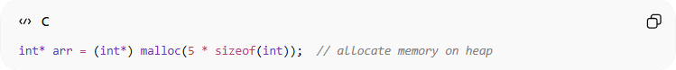
int* arr = (int*) malloc(5 * sizeof(int)); // allocate memory on heap
Example in Java:
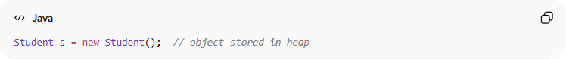
Student s = new Student(); // object stored in heap

2. Manual or Automatic Deallocation
Heap memory must be freed when no longer needed.
- In C/C++ → Programmer frees memory manually.
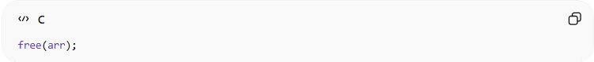
free(arr);
- In languages like Java, Python, C# → A garbage collector automatically releases unused memory.

3. Flexible Size
The heap is larger and more flexible than the stack.
Programs can request memory of different sizes during execution.

4. Slower than Stack
Accessing heap memory is usually slower than stack memory because:
- Allocation is more complex.
- Memory locations may not be contiguous.

Heap Memory Structure Example
# Source: AI Source: Provided by: [Data Path: Persons Table -> ID Column: 1, Name_En Column: Motasem Essam] -> From: [Chatgpt (GPT‑5 Mini)] on [12/10/2025]
If a program creates three objects dynamically:
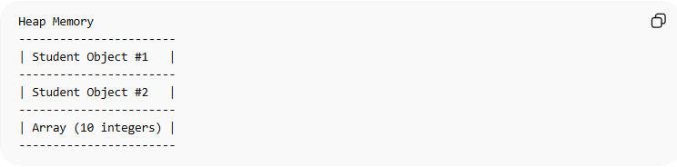
Heap Memory
-----------------------
| Student Object #1 |
-----------------------
| Student Object #2 |
-----------------------
| Array (10 integers) |
-----------------------
Each object occupies a block of memory in the heap.

Example of Heap Usage
# Source: AI Source: Provided by: [Data Path: Persons Table -> ID Column: 1, Name_En Column: Motasem Essam] -> From: [Chatgpt (GPT‑5 Mini)] on [12/10/2025]
Suppose we create a student record dynamically:
Student* s = new Student();
Memory layout:
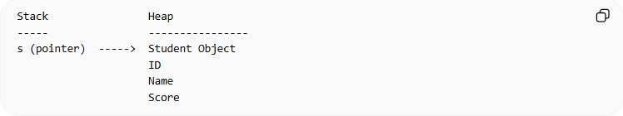
Stack Heap
----- ----------------
s (pointer) -----> Student Object
ID
Name
Score
- The pointer s is stored in the stack.
- The actual object is stored in the heap.

Common Problems with Heap Memory
# Source: AI Source: Provided by: [Data Path: Persons Table -> ID Column: 1, Name_En Column: Motasem Essam] -> From: [Chatgpt (GPT‑5 Mini)] on [12/10/2025]
- Memory Leak
Memory allocated but never freed.
- Fragmentation
Heap becomes divided into many small blocks.
- Slower Allocation
Compared to stack operations.

1. Memory Leak
# Source: AI Source: Provided by: [Data Path: Persons Table -> ID Column: 1, Name_En Column: Motasem Essam] -> From: [Chatgpt (GPT‑5 Mini)] on [12/10/2025]
Definition
A memory leak occurs when a program allocates memory in the heap but never releases it, even after the memory is no longer needed.
How It Happens
When memory is allocated dynamically (for example using malloc() or new), the program must explicitly free it using free() or delete. If the programmer forgets to do this, the memory remains occupied.
Example
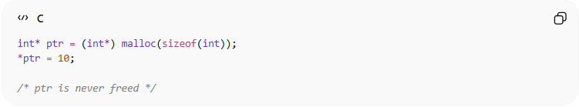
int* ptr = (int*) malloc(sizeof(int));
*ptr = 10;

/* ptr is never freed */
Here:
- Memory is allocated for an integer.
- The program finishes using it.
- But the memory is never released, causing a leak.
Why It Is a Problem
Over time:
- More and more memory remains allocated.
- Available memory decreases.
- The program may slow down or crash due to lack of memory.
Real-World Example
A server program running for weeks may continuously leak memory until the system runs out of RAM.

2. Fragmentation
# Source: AI Source: Provided by: [Data Path: Persons Table -> ID Column: 1, Name_En Column: Motasem Essam] -> From: [Chatgpt (GPT‑5 Mini)] on [12/10/2025]
Definition
Fragmentation occurs when the heap memory becomes broken into many small unused blocks scattered throughout memory.
Even if the total free memory is large, it may not be contiguous, making it difficult to allocate large blocks.
How It Happens
When programs repeatedly:
- Allocate memory
- Free memory
- Allocate different-sized memory blocks
Example sequence:
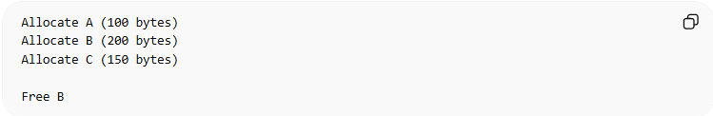
Allocate A (100 bytes)
Allocate B (200 bytes)
Allocate C (150 bytes)

Free B
Memory layout:
[A][ Free ][C]
If the program now needs 250 bytes, it cannot fit into the free space even if total free memory exists elsewhere.
Types of Fragmentation
External Fragmentation
- Free memory is split into many small pieces.
Example:
[Used][Free][Used][Free][Used]
Internal Fragmentation
- Allocated memory block is larger than the data stored inside it, wasting space.
Example:
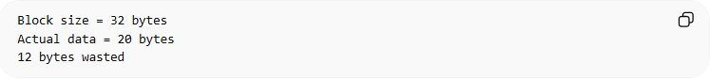
Block size = 32 bytes
Actual data = 20 bytes
12 bytes wasted
Why It Is a Problem
- Makes memory inefficient.
- Large allocations may fail.
- System performance can degrade.

3. Slower Allocation
# Source: AI Source: Provided by: [Data Path: Persons Table -> ID Column: 1, Name_En Column: Motasem Essam] -> From: [Chatgpt (GPT‑5 Mini)] on [12/10/2025]
Definition
Allocating memory in the heap is slower than stack allocation.
Why Heap Allocation Is Slower
1. Memory Searching
The system must search the heap to find a free block large enough for the request.
2. Metadata Management
The heap maintains information about free and used blocks, which must be updated during allocation and deallocation.
3. Fragmentation Handling
The system may need to:
- split memory blocks
- merge free blocks
- reorganize memory
All these steps add overhead.
Example Comparison
Stack allocation:
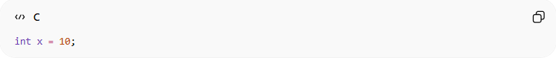
int x = 10;
- CPU simply moves the stack pointer.
Heap allocation:
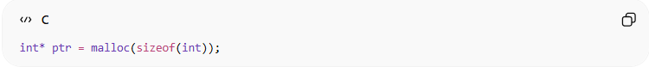
int* ptr = malloc(sizeof(int));
Steps include:
- Search free memory block
- Allocate block
- Update heap metadata
- Return pointer
Because of these steps, heap allocation is slower.

Summary
# Source: AI Source: Provided by: [Data Path: Persons Table -> ID Column: 1, Name_En Column: Motasem Essam] -> From: [Chatgpt (GPT‑5 Mini)] on [12/10/2025]
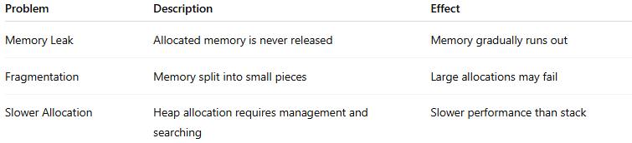
Problem | Description | Effect
Memory Leak | Allocated memory is never released | Memory gradually runs out
Fragmentation | Memory split into small pieces | Large allocations may fail
Slower Allocation | Heap allocation requires management and searching | Slower performance than stack

Stack vs Heap (Quick Comparison)
# Source: AI Source: Provided by: [Data Path: Persons Table -> ID Column: 1, Name_En Column: Motasem Essam] -> From: [Chatgpt (GPT‑5 Mini)] on [12/10/2025]
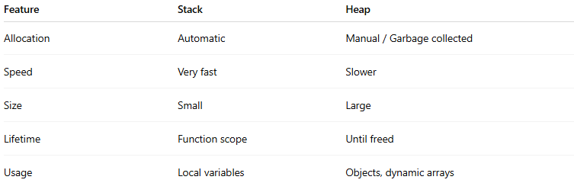
Feature | Stack | Heap
Allocation | Automatic | Manual / Garbage collected
Speed | Very fast | Slower
Size | Small | Large
Lifetime | Function scope | Until freed
Usage | Local variables | Objects, dynamic arrays

✅ In summary:
# Source: AI Source: Provided by: [Data Path: Persons Table -> ID Column: 1, Name_En Column: Motasem Essam] -> From: [Chatgpt (GPT‑5 Mini)] on [12/10/2025]
Heap memory stores dynamically created data that must persist during program execution, giving programs flexibility to allocate memory when needed.

